Circle Language Spec: Black Boxes

Assignment between Friend Members
A connection or assignment always involves two objects. In a connection or assignment that involves a friend object, the access mark is a wavy line. It is only clear which of the objects are friend-accessed from the friend access connectors.

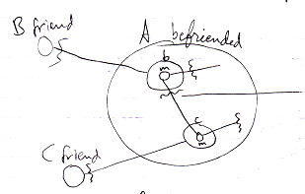

In the example above both members involved in the connection are friend. It is only clear which objects in the access are friend from the presence or absence of a friend access connector.

In the following example, one of the members is public while the other one is private.

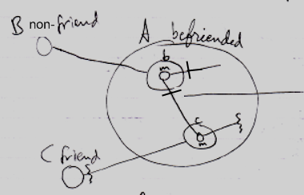

Member m of reference b is Get-public. The access mark of the connection is changed to a Public access mark, because the Get-access is public, and an access mark expresses the Get-access. To see which member involved in a connection or assignment is friend, you should look at the access connectors and not necessarily at the access mark on the connection or assigment call.

